Lab # 11

Shell Control Structures

I. The if Statement

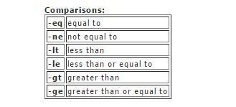
Remember that the spacing is very important in the if statement. Notice that the termination of the if statement is f i. You will need to use the fi statement to terminate an if whether or not use use an else as well. You can also replace the "==" with "!=" to test if the variables are NOT equal. There are other tokens that you can put in place of the "==" for other types of tests . The following table shows the different expressions allowed.

a) The if Statement

Example: Sum two integers

$ vi suminteger.sh

# To find sum of two integral values
if [$# -ne 2] then echo “Please input two integer values”
exit1 fi
echo “Sum of $1 & $2 is `expr $1+$2`”

$ ./suminteger.s
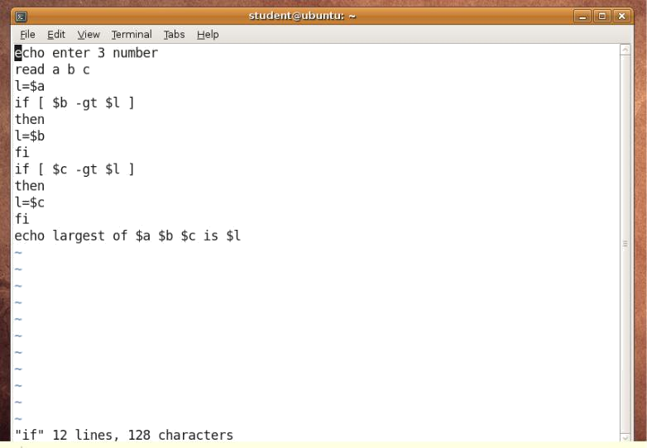
b) Multilevel if... then... elif... else... fi
Example: Find largest no. among 3 given nos.

$vi largest

#largest no.
If [$# -ne 3]
then
echo “Please give 3 nos.”
read n1
read n2
read n3
fi
n1 = $1
n2 = $2
n3 = $3
if [$n1 –gt $n2]
then
if [$n1 –gt $n3]
then
echo “$n1 is largest”
else
echo “$n3 is largest”
fi
elif [$n2 –gt $n3]
then
echo “$n2 is largest”
else
echo “$n3 is largest”
fi
fi

II. while... do... done

Example: Display 1 to 10 nos.

#while loop

count=1 while [$count –le 10] do echo $count count = `expr $count + 1`
done
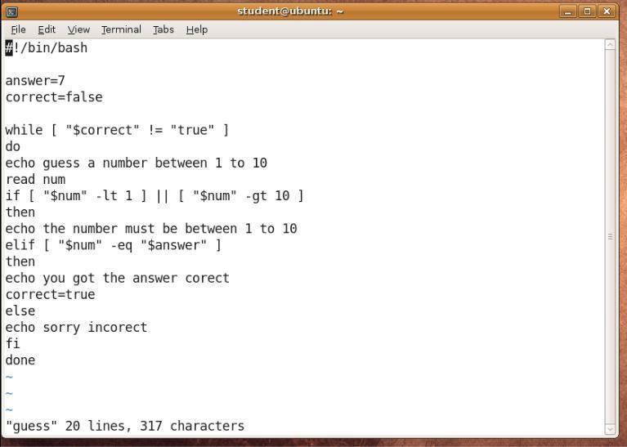

# !/ b i n / b a s h # Guess the number game.

ANSWER= 5 # The correct answer
CORRECT=false # The correct flag

while [ "$ CORRECT" != "true" ] do
# Ask the user for the number...
echo "Guess a number between 1 and 10 . " read NUM

# Validate the input ...

$./while.sh

if [ "$ NUM" -lt 1 ] || [ "$ NUM" - gt 10 ];
then
echo "The number must be between 1 and 10!"
elif [ "$ NUM" -eq "$ ANSWER" ];
then
echo "You got the answer correct!"
CORRECT=true
else
echo "Sorry, incorrect . "
fi
done

III. for... do... done

fori in 1 2 3 4 5 do

{ code} done

The fo r statement is used when you want to loop through a list of items . The body of the loop is put between do and do ne. Let's say that we want to write a program that will validate numbers in a given list. These numbers can be loaded from a file, hard coded, or manually entered by the user. For our example, we will ask the user for a list of numbers separated with spaces. We will validate each number and make sure that it is between 1 and 100. The best way to writ e a program like this would be to use a for loop.
# !/ b i n / s h
# Validate numbers...

echo "Please enter a list of numbers between 1 and 100 . " read NUMBERS

for NUM in $ NUMBERS do
if [ "$ NUM" -lt 1 ] || [ "$ NUM" - gt 100 ]; then
echo "Invalid Number ($ NUM) - Must be between 1 and 100!"
else echo "$ NUM is valid . "
fi
done

Please enter a list of numbers between 1 and 100 .
1435548120100041
1 is valid .
4 is valid . 3 is valid .
55 is valid . 48 is valid .

InvalidNumber (120 )-Must be between 1 and 100 !
InvalidNumber (1000 ) -Must be between 1 and 100 !
4 is valid .
1 is valid .

a) Nested Loop

Example: All combination of nos. 1,2& 3

a=1
while [ $a –le 3]
do
b=1
while [$b –le 3]
do
c=1
while [$c –le 3]
do
echo “$a$b$c”
c=`expr $c+1`
done
b=`expr $b+1`
done
a=`expr $a+1`
done
$./nested.sh

Lab Tasks

- Write a program to generate the following output by using while loop
The value of x is 10
The value of x is 9
The value of x is 8
The value of x is 7
The value of x is 6
The value of x is 5
The value of x is 4
The value of x is 3
The value of x is 2
The value of x is 1

- Write a program to generate the table of any number by using for loop.

3.Write a program to generate the factorial of a number.

4.Write a program to show the grades and % of students (with students details).

